Outputs
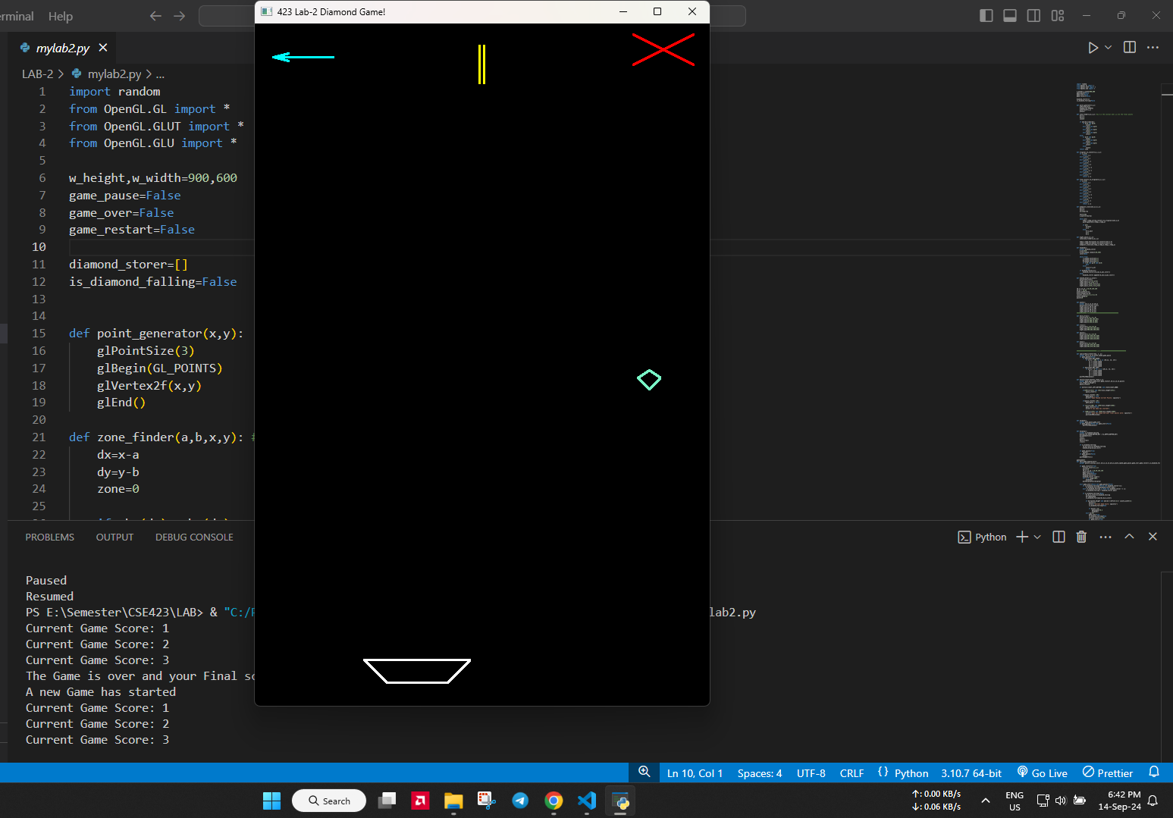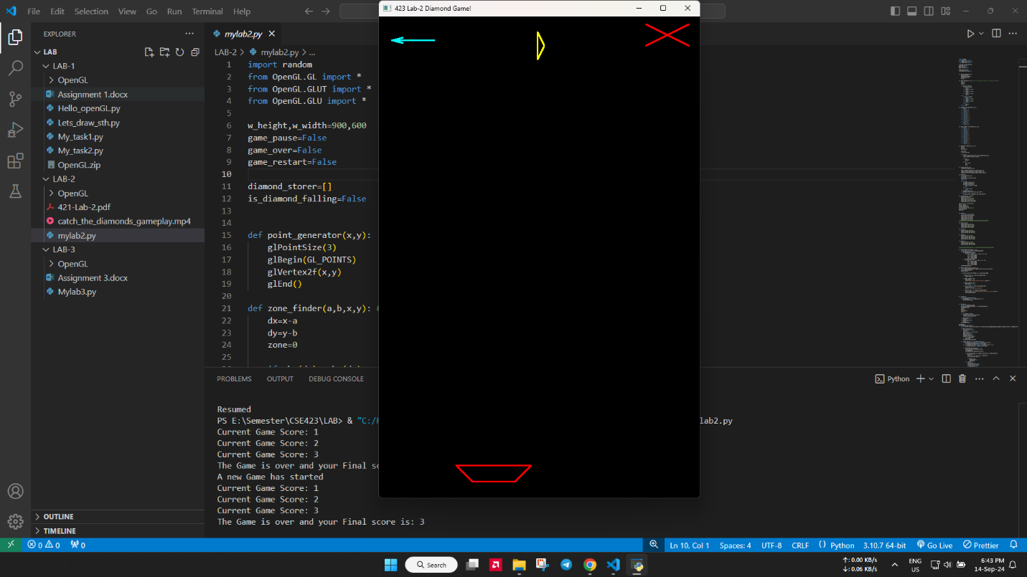

Code: https://colab.research.google.com/drive/11MLenNR0X_GGSEBHbD7O_7k2CPNd_5aN?usp=sharing

